Lab Title: Network Scanning and Reconnaissance with Nmap on Kali Linux
Objective:
Students will learn to:
- Discover live hosts on a network.
- Perform and interpret different Nmap scans.
- Identify open ports, services, and potential vulnerabilities.
Prerequisites:
- Kali Linux installed with Nmap.
- Test network (local lab network or multiple virtual machines) with assigned IP addresses for scanning.

Lab Setup:
- Kali Linux VM: The main tool for running Nmap.
- Target VMs or Devices: At least one target to scan, ideally with varied OS and services.

Lab Tasks:
Task 1: Introduction to Nmap
- Objective: Familiarize students with the Nmap syntax and available options.
- Command: Open a terminal and type nmap -h.
- Discussion: Review basic Nmap commands and scan types.
Task 2: Basic Network Discovery
- Identify the Network: Use ifconfig or ip a to find the IP address and subnet of the Kali VM.
  - Example: If the IP address is 192.168.1.10/24, the network range is 192.168.1.0/24.
[Screenshot above command x2]
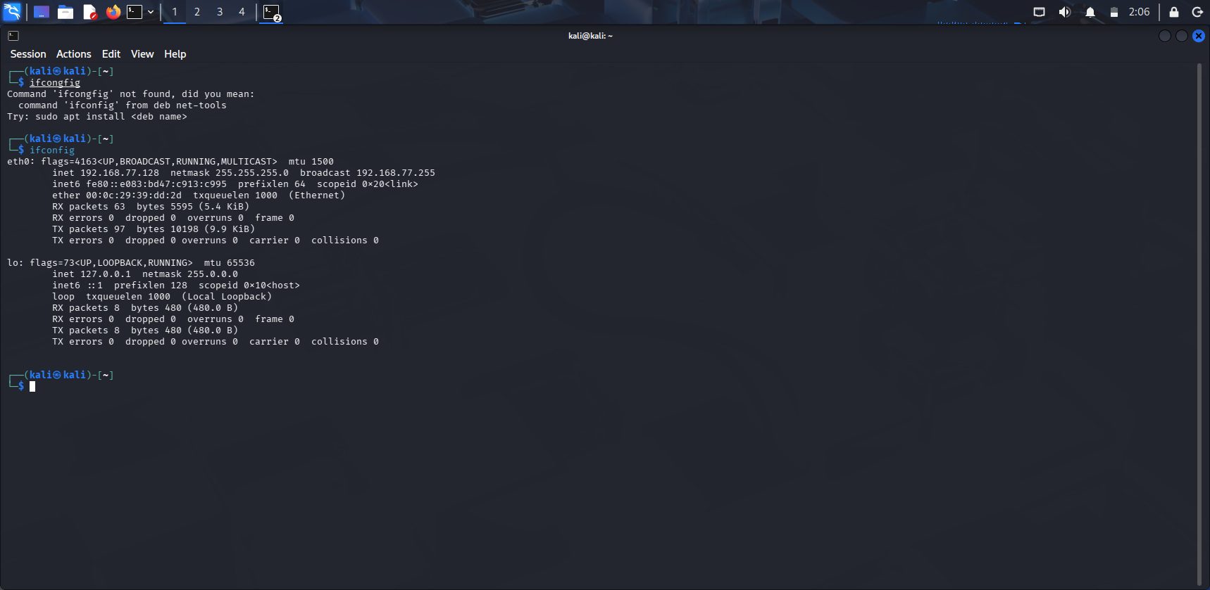

- Ping Scan: Discover active devices on the network.
nmap -sn 192.168.1.0/24
  - Expected Output: A list of IP addresses for active hosts. (Only devices responding to ping will show.)
[Screenshot above command x1]
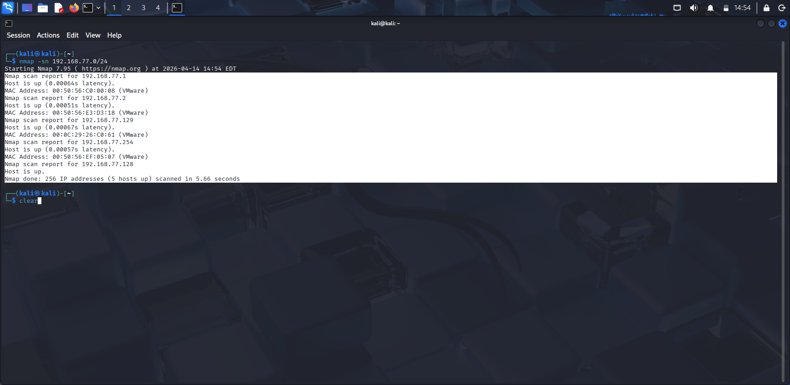

Task 3: Port Scanning and Service Detection
TCP SYN Scan: Scan an active host (e.g., 192.168.1.5) to find open ports.
nmap -sS 192.168.1.5
- Expected Output: A list of open ports on the target IP, e.g., port 22 (SSH), port 80 (HTTP).
Screenshot above command x1]
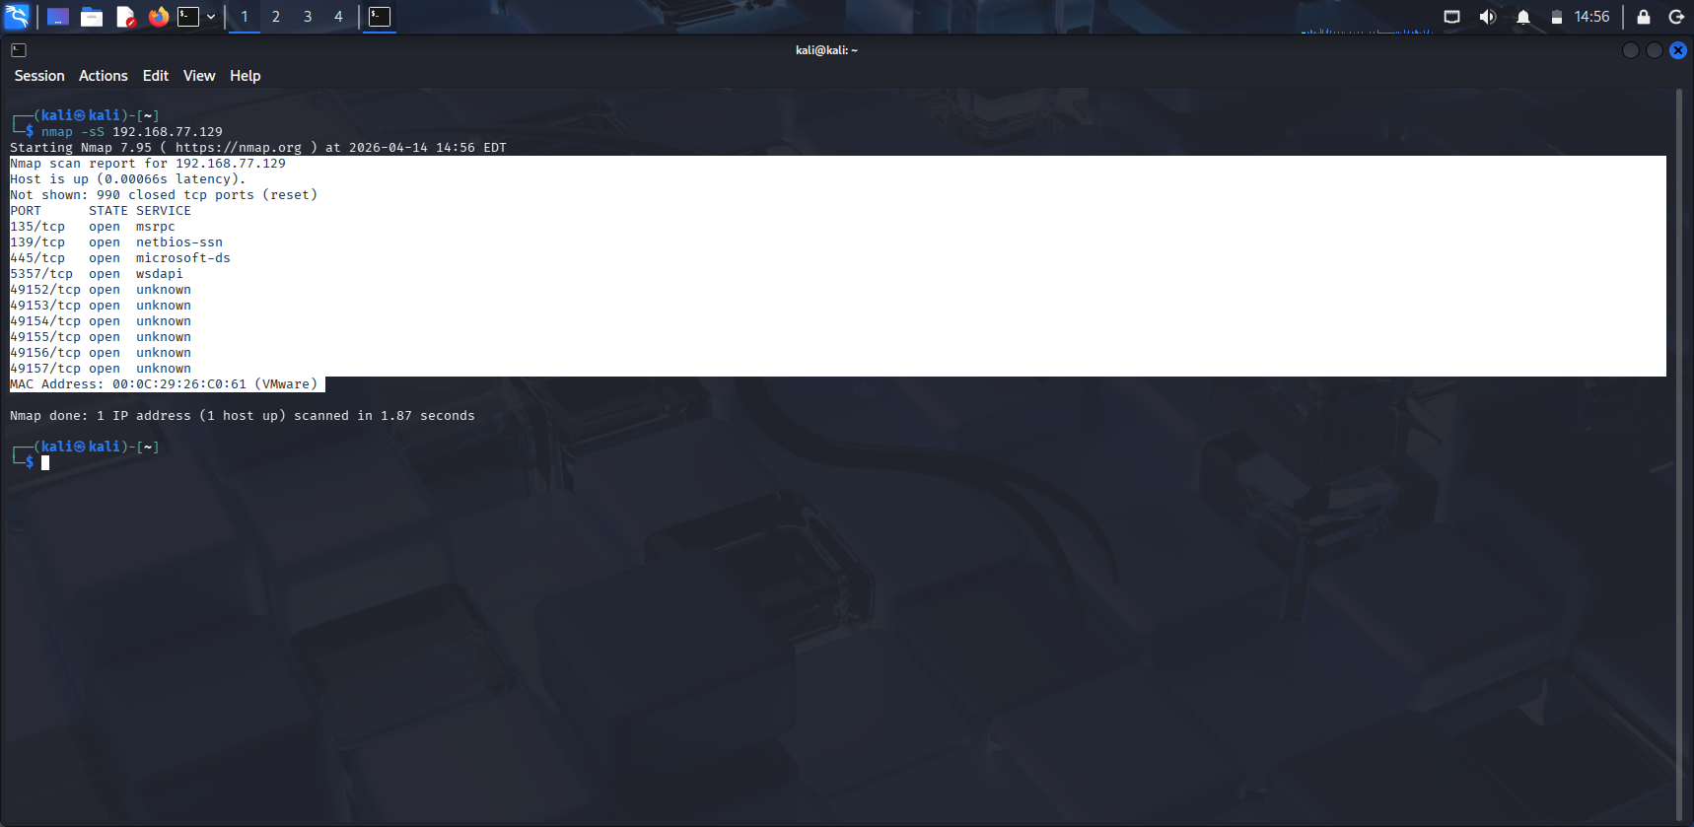

Service Version Detection: Identify services running on open ports.
nmap -sV 192.168.1.5
Example Output:
PORT STATE SERVICE VERSION
22/tcp open ssh OpenSSH 7.9
80/tcp open http Apache httpd 2.4.29
[Screenshot above command x1]
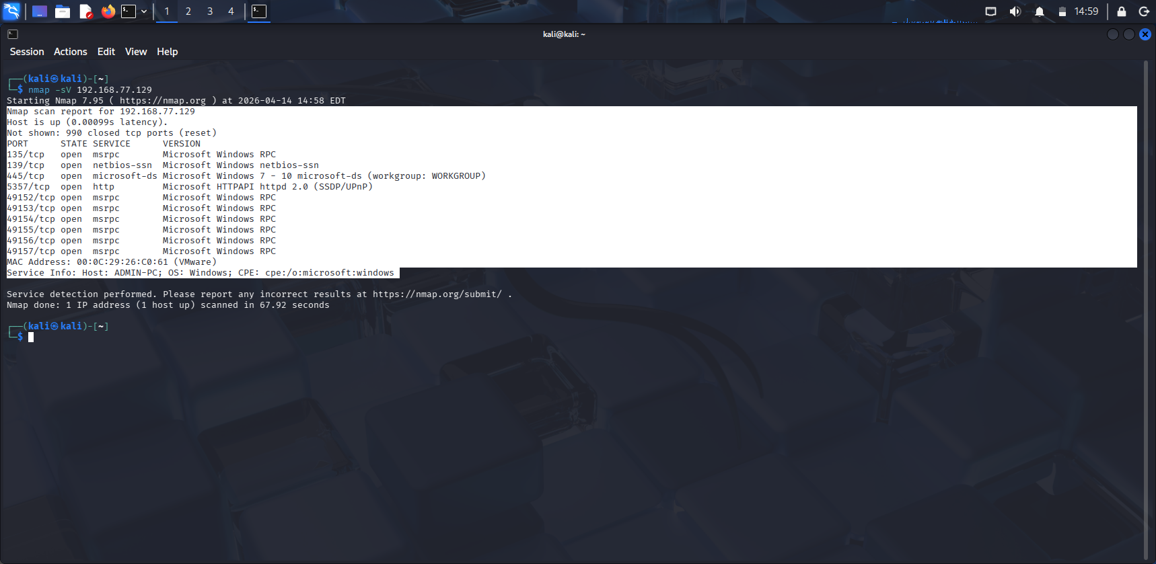

Task 4: Operating System Detection
- Objective: Identify the operating system of the target.
- Command:
  - nmap -O 192.168.1.5
- • Expected Output: Nmap’s best guess of the OS, e.g., Linux or Windows version.
- • Discussion: Review how OS detection works and why it may not be 100% accurate.
[Screenshot above command x1]
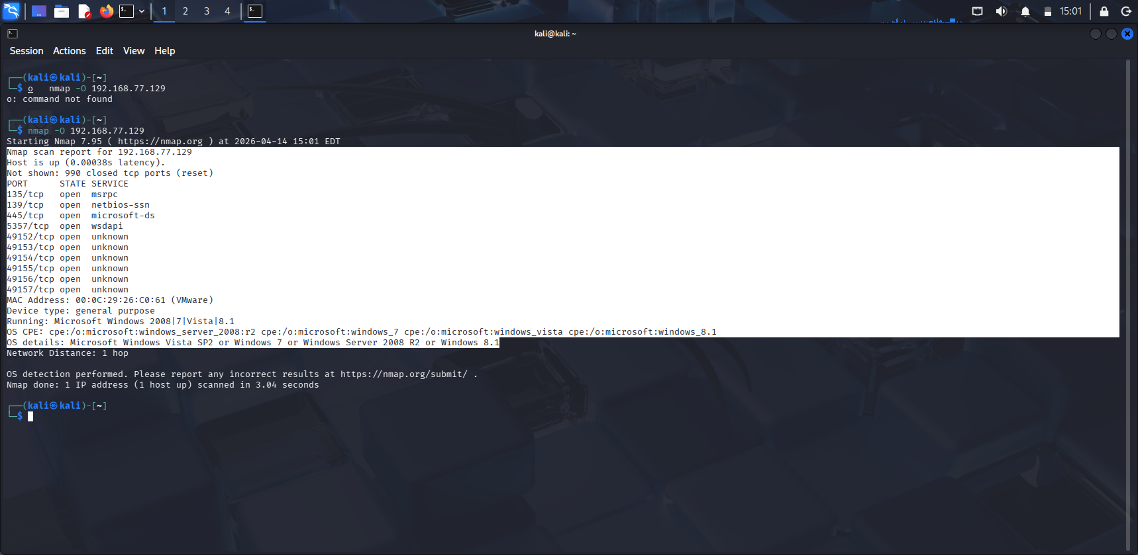

Task 5: Vulnerability Detection Using Nmap Scripts
- Vulnerability Script Scan: Use Nmap's NSE scripts to scan for known vulnerabilities.
nmap --script vuln 192.168.1.5
Example Output:

PORT STATE SERVICE
80/tcp open http
http-vuln-cve2020-3452:
VULNERABLE:
Cisco ASA and FTD HTTP Response Vulnerability
State: VULNERABLE
Discussion: Emphasize the need for responsible use of these scans and ethical considerations in real-world settings.
[Screenshot above command x1]
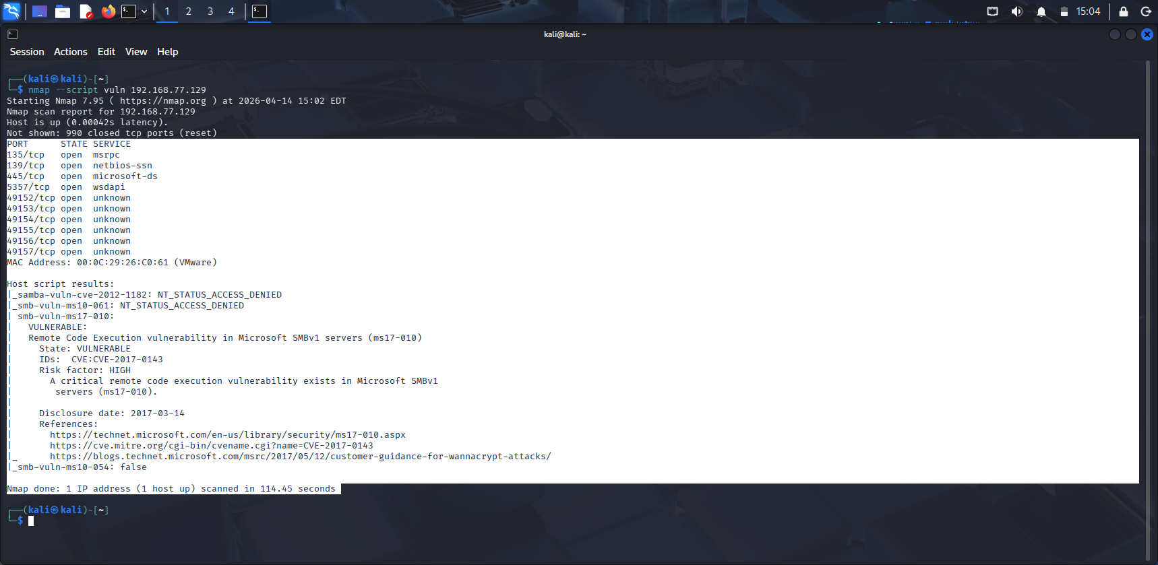

Task 6: Evading Detection
- Objective: Use Nmap’s -Pn option to avoid pinging the target, which may bypass firewall detection.
- Command:
nmap -Pn 192.168.1.5
  - Expected Outcome: A scan result for the host without checking if it is live, useful if ICMP is blocked.
[Screenshot above command x1]
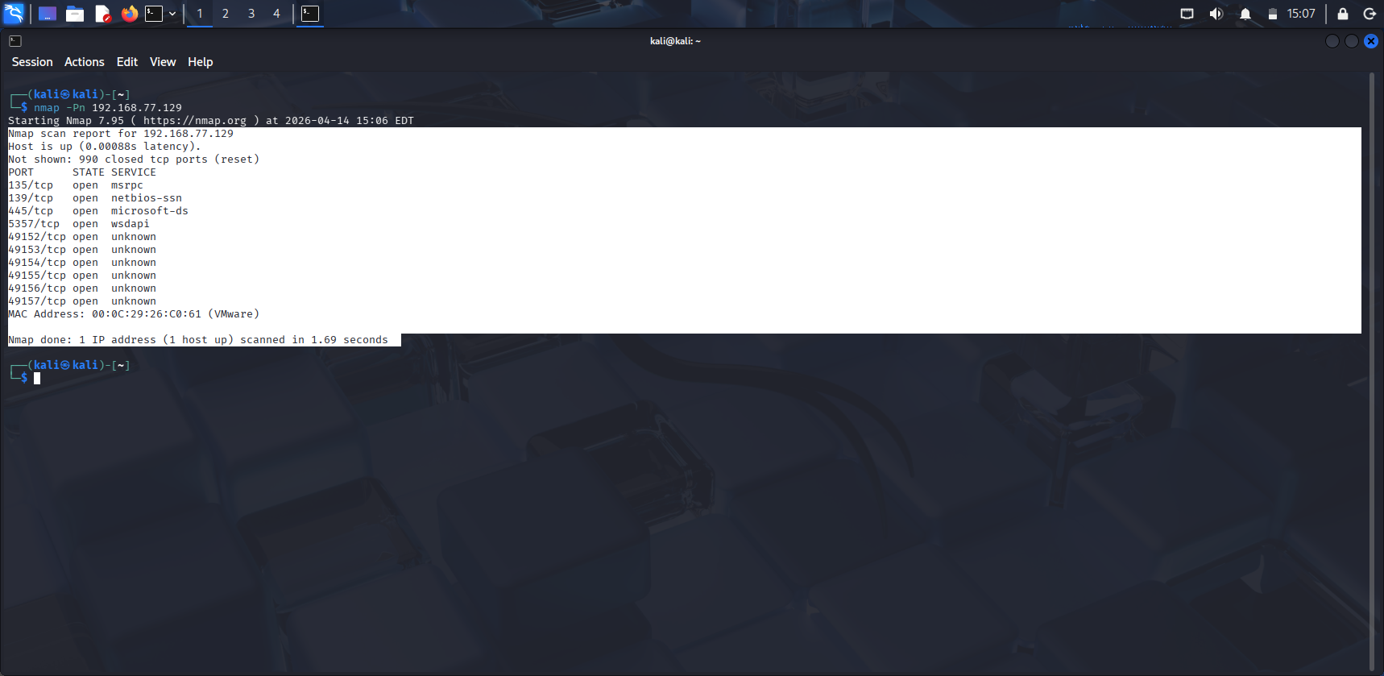
Task 7: Reporting and Analysis
- Save Scan Results: Use -oN or -oX to save output in human-readable or XML formats.
nmap -oN scan_report.txt -sS 192.168.1.5
Review the Report: Open scan_report.txt and interpret the data.
[Screenshot above command x1]
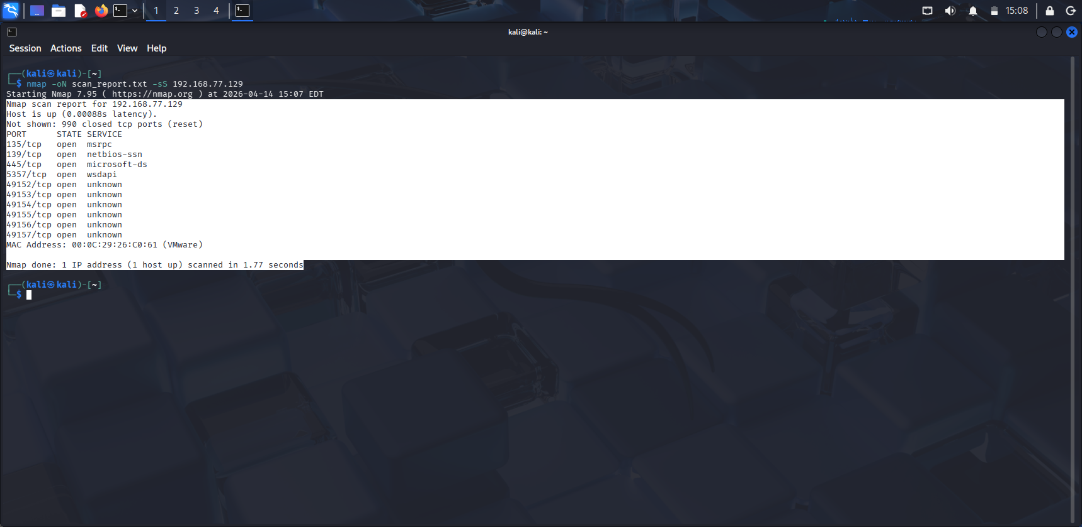
Discussion Points:
- How attackers might exploit open ports or vulnerabilities.
- Strategies for network defenders to harden their systems against such scans.
References:
- https://nmap.org/book/man-host-discovery.html
- https://www.geeksforgeeks.org/linux-unix/top-30-basic-nmap-commands-for-beginners/
- https://www.geeksforgeeks.org/ethical-hacking/nmap-cheat-sheet/

